Background:

Welcome to the United States Geological Survey, or USGS for short! The USGS is responsible for providing scientific data about natural hazards, the health of our ecosystems and environments; and the impacts of climate and land-use change. Their scientists develop new methods and tools to supply timely, relevant, and useful information about the Earth and its processes. As a new hire, you will be helping them out with an exciting new project!

The USGS is interested in building a new set of tools that will allow them to visualize their earthquake data. They collect a massive amount of data from all over the world each day, but they lack a meaningful way of displaying it. Their hope is that being able to visualize their data will allow them to better educate the public and other government organizations (and hopefully secure more funding...) on issues facing our planet.

Level 1 Task:

My first task is to visualize an earthquake data set. The USGS provides earthquake data in several different formats, updated every 5 minutes. To get the data, I visited the USGS GeoJSON Feed (<https://earthquake.usgs.gov/earthquakes/feed/v1.0/geojson.php>) page and picked the “ALL Earthquakes from the Past 7 Days”. I will use the URL of this JSON to pull in the data for our visualization. Next create a map using Leaflet that plots all the earthquakes from the data set based on their longitude and latitude.

* Data markers reflect the magnitude of the earthquake in their size and color. Earthquakes with higher magnitudes appear larger and darker in color.

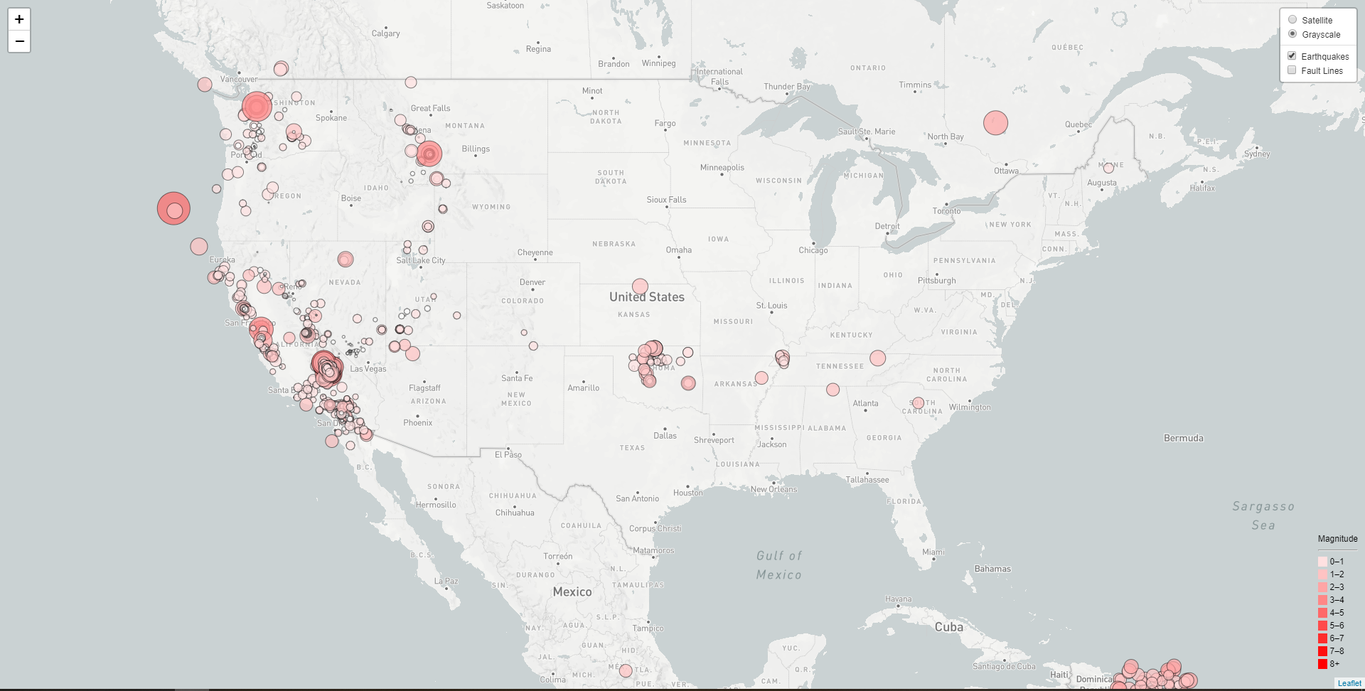

* Popups was added to provide additional information about the earthquake when a marker is clicked.
* A legend was also created and placed on the map at the bottom right corner.

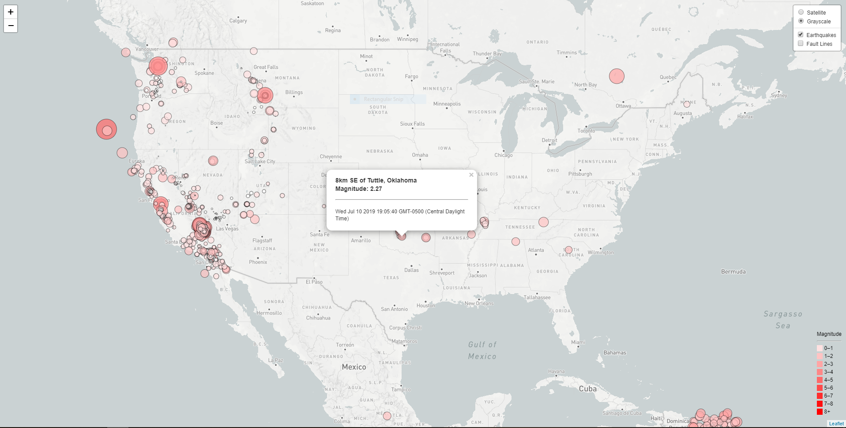

Level 2 Tasks (Optional):

The USGS wants to plot a second data set on your map to illustrate the relationship between tectonic plates and seismic activity. I will add a second data set and visualize it alongside the original set of data. Data on tectonic plates can be found at <https://github.com/fraxen/tectonicplates/blob/master/GeoJSON/PB2002_boundaries.json>

* Plot a second data set on the map
* Add a number of base maps to choose from as well as separate out the two different data sets into overlays that can be turned on and off independently.
* Add layer controls to the map

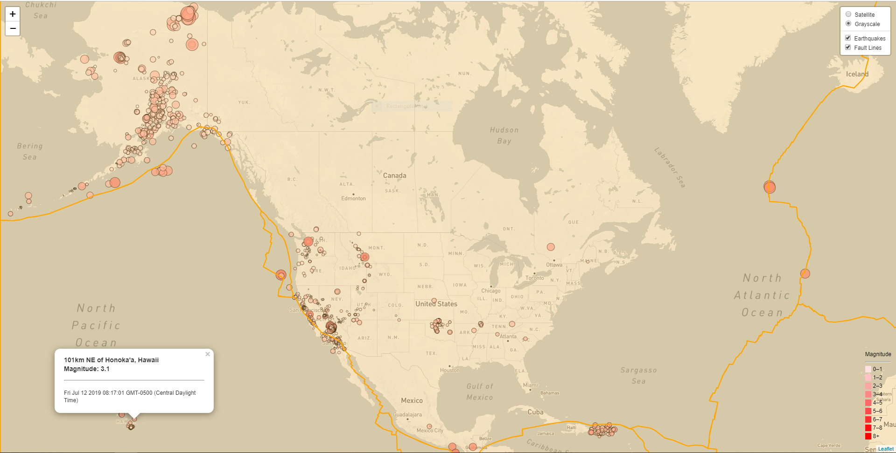

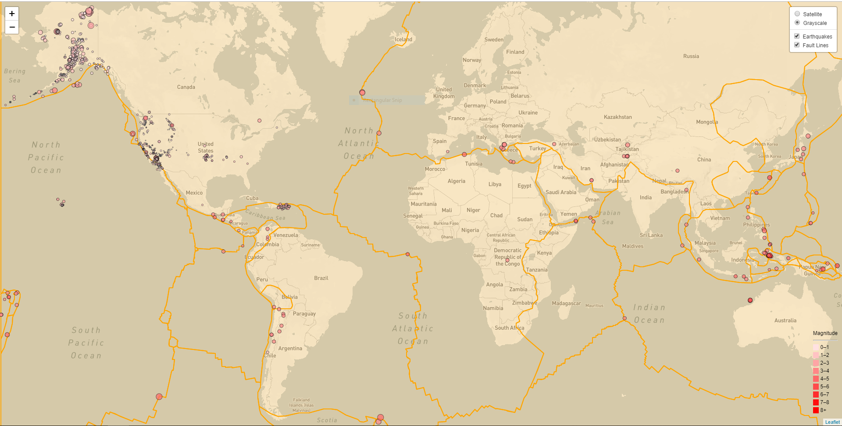

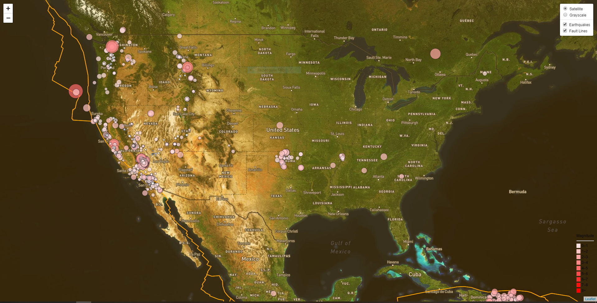

Conclusion:

Most seismic activities for the past 7 days have been recorded in North America. Specifically, in the Unites States (Alaska and California) much of the seismic activities fall between 1 and 3; which is mostly undetectable for most people.